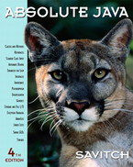 COSC 1320
Name: _________________ Seat # __

Estimated Hours 1
Actual Hours

TA (Textual Analysis) for UML USE CASE Diagram MODEL
Programming Assignment 2:
(10 points)
(Due date found in the COSC 1320 BB Calendar!)
You must use Microsoft WORD program. Insert the TEMPLATEs for Actors and Use Cases in this Requirements Document.

Please have Step 1, 2, 3, and 4 in this order.

PLEASE use the “TA for UML USE CASE Diagram MODEL Movie Company System.doc” AS TEMPLATE.
(Do not Show STEP 1,…; do not change Line Numbers; do not change Number of Pages)

Any DIAGRAM that is NOT the result of CUT and PASTE
WILL BE IGNORED. (YOU WILL GET ZERO POINTS)

Requirements Analysis: Construct the UML USE CASE Diagram MODEL

ProgrammingAssignment2 APPLICATION for ANIMATING an electrical CIRCUIT using SWING.

Write an application that controls an electrical circuit that has a power source, a switch, and a light bulb. The user wants to control the names of the Labels, thus they must be read from a data file named “Programming Assignment 2 Data.txt”.

A sample input file “Programming Assignment 2 Data.txt” follows:
Animation of an Electrical Circuit
Power Supply
Switch
Light bulb

You will have two buttons, labeled Open and Close. When you click on Close (see that the switch shows that it is closed - redraw) the light bulb should turn on. When you click on Open (see that the switch shows that it is open - redraw) the light bulb should turn off.

The title of your window must be “Programming Assignment 2”.

Create a ProgrammingAssignment2.java that contains the main method.
JAVA Exception Handling is also required.

You cannot use a GUI Designer!
One Class per .java file!
Look up Chapter 18 for drawing JAVA Classes).

Each .java file must have these 4 lines of comments (you will lose 5 points if not):
// COSC 1320 Summer 2015
// Name:
// Programming Assignment 2
// This is my own work; I will not post

PLEASE DO NOT INCLUDE THESE PAGES AS YOUR DELIVERABLES! This is just for your use. Please have Step 1, then 2, etc. order in your deliverables.

TA (Textual Analysis) for UML USE CASE Diagram MODEL
for Movie Company System
A1: User

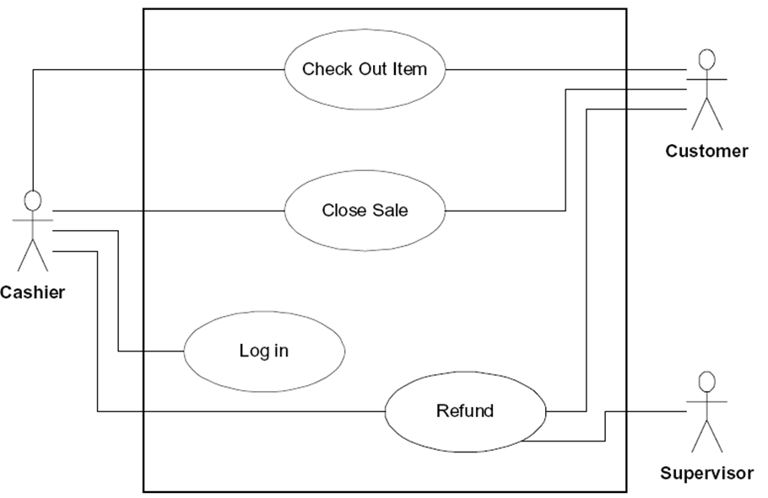

The Movie Company has the following affiliated Artists (maximum 10):

“Miles Davis”, with 3 Discs:
Disc 1: Title “Miles Ahead” with Track “Miles Ahead” that is 3.34 minutes
Disc 2: Title “Tutu with Tracks: “Tutu”, 4.56, “Portia”, 3.34, “Tomaas”, 3.56
Disc 3: Title “Kind of Blue” with Tracks “So What”, 4.54, “Freddie Freeloader, 5.25, “Blue in Green”, 2.56
“John Coltrane”, with 1 Disc:
Disc 1: Title “Blue Train” with Blue Train” that is 5.15 minutes; “Moments Notice”, 5.52, “Locomotion”, 6.18

The Movie Company wants to keep a catalog of its artists and their discs (maximum 30). Artists have a name. The Movie Company can add an artist or get a listing of all its artists.
UC1: UCAddArtist
UC2: UCListArtists
Each artist produces music Discs. A Disc is associated with an Artist. A Disc is cataloged with a disc catalogNumber. The Movie Company can add a disc or get a listing of all its discs.
UC3: UCAddDisc
UC4: UCListDiscs
A Disc has a number of Tracks. The Track has a title and a duration time. A Disc has a catalogNumber , a title, the number of tracks. The Movie Company can add a track or get a listing of all tracks for a given disc.
UC5: UCAddTrack
UC6: UCListTracksForDiscs
UC7: UCRestoreCatalog
UC8: UCSaveCatalog
UCAddArtist
UCListArtists
UCAddDisc
UCListDiscs
UCAddTrack
UCListTracksForDisk
Controller

UC 1

UC2

UC3

UC4

UC5

UC6

UC7

UC8

UCRestoreCatalog
UCSaveCatalog
A1: User

UC1 UCAddArtist Description
Name: | UCAddArtist
Actor: | User
Description: | This use case describes the process used by User to Add another Artist
Successful Completion: | User requests Adding Artist by artistName  - Movie Company System checks to see if not already there and there is room  - Artist artistName is added and successful message is sent to the User
Alternative: | User requests Adding Artist by artistName  - Movie Company System checks to see if not already there and there is room  - If artistName either ALREADY present or NO MORE ROOM MAX_ARTISTS Artist artistName is NOT added and UNsuccessful message is sent to the User
Pre-Condition: | User requests Add Artist
Post-Condition: | Artist artistName Added successfully or UNsuccessfully
Assumptions: | None

UC2 UCListArtists Description
Name: | UCListArtists
Actor: | User
Description: | This use case describes the process used by User to List all Artists
Successful Completion: | User requests Listing Artists  - Movie Company System displays all the Artists
Alternative:
Pre-Condition: | User requests List Artists
Post-Condition: | Artists displayed
Assumptions: | None

UC3 UCAddDisc Description
Name: | UCAddDisc
Actor: | User
Description: | This use case describes the process used by User to Add another Disc for a particular artistName
Successful Completion: | User requests Adding Disc to artistName  - Movie Company System prompts for discCatalogNumber  - Movie Company System prompts for disc  - Disc discCatalogNumber , disc is Added to Artist artistName and successful message is sent to the User
Alternative: | User requests Adding Disc to artistName  - Movie Company System prompts for discCatalogNumber  - Movie Company System prompts for disc  - Movie Company System checks to see if not already there and there is room  - If disc either ALREADY present or NO MORE ROOM MAX_DISCS Disc disc is NOT added and UNsuccessful message is sent to the User
Pre-Condition: | User requests Add Disc
Post-Condition: | Disc discCatalogNumber, disc Added to Artist artistName successfully or UNsuccessfully
Assumptions: | None

UC4 UCListDiscs Description
Name: | UCListDiscs
Actor: | User
Description: | This use case describes the process used by User to List all Discs
Successful Completion: | User requests Listing Discs  - Movie Company System displays all the Discs, discCatalogNumber, title, artistName
Alternative:
Pre-Condition: | User requests List Discs
Post-Condition: | Discs displayed
Assumptions: | None
UC5 UCAddTrack Description
Name: | UCAddTrack
Actor: | User
Description: | This use case describes the process used by User to Add another Track trackTitle, time for a particular discCatalogNumber
Successful Completion: | User requests Adding Track to Disc discCatalogNumber  - Movie Company System prompts for trackTitle  - Movie Company System prompts for time  - Track trackTitle, time is Added to Disc discCatalogNumber and successful message is sent to the User
Alternative: | User requests Adding Track to Disc discCatalogNumber  - Movie Company System prompts for trackTitle  - Movie Company System prompts for time  - Movie Company System checks to see if not already there and there is room  - If trackTitle either ALREADY present or NO MORE ROOM MAX_TRACKS Track trackTitle is NOT added and UNsuccessful message is sent to the User
Pre-Condition: | User requests Add Track
Post-Condition: | Track trackTitle, time Added to Disc discCatalogNumber successfully or UNsuccessfully
Assumptions: | None

UC6 UCListTracksForDisc Description
Name: | UCListTracksForDisc
Actor: | User
Description: | This use case describes the process used by User to List all Tracks title for a Disc discCatalogNumber
Successful Completion: | User requests Listing Discs  - Movie Company System displays all the Tracks title for Disc discCatalogNumber
Alternative:
Pre-Condition: | User requests List Tracks for Disc
Post-Condition: | Tracks for Disc displayed
Assumptions: | None

